**Clinical Decision Support (CDS) Content and Health Level 7 (HL7)-Compliant Knowledge Artifacts (KNARTs)**

**Gastroenterology: Hepatitis C Clinical Content White Paper**

**Department of Veterans Affairs (VA)**



**Knowledge Based Systems (KBS)**

**Office of Informatics and Information Governance (OIIG)**

**Clinical Decision Support (CDS)**

**Clinical Decision Support (CDS) Content and Health Level 7 (HL7)-Compliant Knowledge Artifacts (KNARTs): Gastroenterology: Hepatitis C Clinical Content White Paper**

by Department of Veterans Affairs (VA)

Publication date March 2018

**Contract: VA118-16-D-1008, Task Order (TO): VA-118-16-F-1008-0007**

**Table 1. Relevant KNART Information: Gastroenterology: Hepatitis C**

| **KNART Name** | **Associated CLIN** |
| --- | --- |
| Hepatitis C- Consult Request/Documentation Template | CLIN0005AD |
| Hepatitis C- Elbasvir/Grazoprevir- Order Set | CLIN0004AC |
| Hepatitis C- Lediposvir/Sofobuvir- Order Set | CLIN0004AC |
| Hepatitis C- Glecaprevir/Pibrentavir- Order Set | CLIN0004AC |
| Hepatitis C- Composite/Consult Request | N/A |

**Table of Contents**

VA Subject Matter Expert (SME) Panel vi

Introduction vii

Conventions Used viii

1. Gastroenterology: Hepatitis C 1

1. Clinical Context 1

2. Knowledge Artifacts 1

2. Composite: Hepatitis C Consult Request 2

1. Knowledge Narrative 2

2. Consult Request 2

3. Documentation Template: Hepatitis C 4

1. Demographics 4

2. Problem List 4

3. Body Mass Index 4

4. Medication List 4

5. History of Present Illness 5

6. Labs 6

7. Imaging 8

4. Order Set: Hepatitis C Elbasvir/Grazoprevir 9

1. Knowledge Narrative 9

2. Medications 9

3. Laboratory Tests 11

4. Patient and Caregiver Education 11

5. Order Set: Hepatitis C Ledipasvir/Sofobuvir 13

1. Knowledge Narrative 13

2. Medications 13

3. Laboratory Tests 15

4. Patient and Caregiver Education 16

6. Order Set: Hepatitis C Glecaprevir/Pibrentasvir 17

1. Knowledge Narrative 17

2. Medications 17

3. Laboratory Tests 18

4. Patient and Caregiver Education 19

Bibliography/Evidence 20

A. Existing Sample VA Artifacts 21

B. Clinical Guidelines 44

C. Basic Laboratory Panel Definition 45

Acronyms 46

**List of Figures**

A.1. Hepatitis C Treatment 21

A.2. Template: Formulary Exception- Hepatitis C Virus (HCV) Output Phenolic Acid-responsive Transcriptional Regulator (PADR) (Image 1 of 5) 22

A.3. Template: Formulary Exception- Hepatitis C Virus (HCV) Output Phenolic Acid-responsive Transcriptional Regulator (PADR) (Image 2 of 5) 23

A.4. Template: Formulary Exception- Hepatitis C Virus (HCV) Output Phenolic Acid-responsive Transcriptional Regulator (PADR) (Image 3 of 5) 24

A.5. Template: Formulary Exception- Hepatitis C Virus (HCV) Output Phenolic Acid-responsive Transcriptional Regulator (PADR) (Image 4 of 5) 25

A.6. Template: Formulary Exception- Hepatitis C Virus (HCV) Output Phenolic Acid-responsive Transcriptional Regulator (PADR) (Image 5 of 5) 26

A.7. Fibrosis- 4 (FIB-4) Calculator (Image 1 of 2) 27

A.8. Fibrosis- 4 (FIB-4) Calculator (Image 2 of 2) 27

A.9. Template: Hepatitis C Virus (HCV) Output Phenolic Acid-responsive Transcriptional Regulator (PADR) (Image 1 of 3) 28

A.10. Template: Hepatitis C Virus (HCV) Output Phenolic Acid-responsive Transcriptional Regulator (PADR) (Image 2 of 3) 29

A.11. Template: Hepatitis C Virus (HCV) Output Phenolic Acid-responsive Transcriptional Regulator (PADR) (Image 3 of 3) 30

A.12. Reminder Dialog Template: Hepatitis C Clinic Subjective Objective Assessment Plan (SOAP) (I &II combined) (Image 1 of 8) 36

A.13. Reminder Dialog Template: Hepatitis C Clinic Subjective Objective Assessment Plan (SOAP) (I &II combined) (Image 2 of 8) 37

A.14. Reminder Dialog Template: Hepatitis C Clinic Subjective Objective Assessment Plan (SOAP) (I &II combined) (Image 3 of 8) 38

A.15. Reminder Dialog Template: Hepatitis C Clinic Subjective Objective Assessment Plan (SOAP) (I &II combined) (Image 4 of 8) 39

A.16. Reminder Dialog Template: Hepatitis C Clinic Subjective Objective Assessment Plan (SOAP) (I &II combined) (Image 5 of 8) 40

A.17. Reminder Dialog Template: Hepatitis C Clinic Subjective Objective Assessment Plan (SOAP) (I &II combined) (Image 6 of 8) 41

A.18. Reminder Dialog Template: Hepatitis C Clinic Subjective Objective Assessment Plan (SOAP) (I &II combined) (Image 7 of 8) 42

A.19. Reminder Dialog Template: Hepatitis C Clinic Subjective Objective Assessment Plan (SOAP) (I &II combined) (Image 8 of 8) 43

**List of Tables**

1. Relevant KNART Information: Gastroenterology: Hepatitis C ii

1.1. Clinical Context Domains 1

A.1. Genotype 1 30

A.2. Genotype 2 31

A.3. Genotype 3 32

A.4. Genotype 4 32

A.5. Genotype 5 and 6 32

A.6. Genotype 1 32

A.7. Genotype 2 34

A.8. Genotype 3 34

A.9. Genotype 4 34

A.10. Genotype 5 and 6 35

**VA Subject Matter Expert (SME) Panel**

| **Name** | **Title** | **Project Role** |
| --- | --- | --- |
| David Kaplan, MD | Staff Physician Gastroenterology Philadelphia, PA | SME, Primary |
| Timothy Morgan, MD | Physician, Long Beach VA Medical Center (VAMC), Long Beach, CA | SME, Secondary |
| James Wilson, MD | Administrative Specialist, Puget Sound Healthcare System, Seattle, WA | SME |
| Jason Dominitz, MD | National Director of Gastroenterology, Puget Sound Healthcare System, Seattle, WA | SME |
| Byron Cryer, MD | Physician, North Texas VA Healthcare System, Dallas, TX | SME |
| Ashley Faulx, MD | Med-GI Fellow, Louis Stokes Cleveland VAMC, Cleveland, OH | SME |
| Lyn Sue Kahng, MD | GI Section Chief, Jesse Brown VAMC, Chicago, IL | SME |
| Heiko Pohl, MD | Physician, White River Junction VAMC, White River Junction, VT | SME |
| Aasma Shaukat, MD | Physician, Minneapolis VAMC Minneapolis, MN | SME |
| Walter Smalley, MD | Physician, Tennessee Valley HCS Nashville, TN | SME |
| Pamela (Pam) Belperio | PharmD/Clinical Pharmacist, Population Health Services Los Angeles, CA | SME |
| Lisa Backus | Deputy Chief Consultant, Population Health Services Palo Alto, CA | SME |

**Introduction**

The VA is committed to improving the ability of clinicians to provide care for patients while increasing quality, safety, and efficiency. Recognizing the importance of standardizing clinical knowledge in support of this goal, VA is implementing the HL7 Knowledge Artifact Specification for a wide range of VA clinical use cases. Knowledge Artifacts, referred to as KNARTs, enable the structuring and encoding of clinical knowledge so the knowledge can be integrated with electronic health records to enable clinical decision support.

The purpose of this Clinical Content White Paper is to capture the clinical context and intent of KNART use cases in sufficient detail to provide the KNART authoring team with the clinical source material to construct the corresponding knowledge artifacts using the HL7 Knowledge Artifact Specification. This paper has been developed using material from a variety of sources: VA artifacts, clinical practice guidelines, evidence in the body of medical literature, and clinical expertise. After reviewing these sources, the material has been synthesized and harmonized under the guidance of VA subject matter experts to reflect clinical intent of this use case for this use case.

Unless otherwise noted, items within this white paper (e.g., documentation template fields, orderable items, etc.) are chosen to reflect the clinical intent at the time of creation. To provide an exhaustive list of all possible items and their variations is beyond the scope of this work.

**Conventions Used**

Conventions used within the knowledge artifact descriptions include:

<obtain>: Indicates a prompt to obtain the information listed

* If possible, the requested information should be obtained from the underlying system(s). Otherwise, prompting the user for information may be required
* Default Values: Unless otherwise noted, <obtain> indicates to obtain the most recent observation. It is recognized that this default time-frame value may be altered by future implementations

[...]: Square brackets enclose explanatory text that indicates some action on the part of the clinical user, or general guidance to the clinical or technical teams. Examples include, but are not limited to:

[Begin ...], [End ...]: Indicates the start and end of specific areas to clearly delineate them for technical purposes.

[Activate ...]: Initiates another knowledge artifact or knowledge artifact section.

[Section Prompt: ...]: If this section is applicable, then the following prompt should be displayed to the user.

[Section Behavior: ...]: Indicates technical constraints or considerations for the selection of items outlined in the section prompt.

[Attach: ...]: Indicates that the specified item (e.g. procedure or result interpretation) should be attached to the documentation template if available.

[Link: ...]: Indicates that rather than attaching an item (e.g. image), a link should be included in the documentation template.

[Clinical Comment: ...]: Indicates technical considerations or notes to be utilized for KNART authoring and at time of implementation planning.

[Technical Note: ...]: Indicates technical considerations or notes to be utilized for KNART authoring and at time of implementation planning.

[If ...]: Indicates the beginning of a conditional section.

[Else, ...]: Indicates the beginning of the alternative branch of a conditional section.

[End if ...]: Indicates the end of a conditional section.

☐ [Check box]: Indicates items that should be selected based upon the section selection behavior.

**Chapter 1. Gastroenterology: Hepatitis C**

**1. Clinical Context**

[Begin Clinical Context.]

Intended to identify patients for whom hepatitis C treatment is recommended; facilitate discussion between the primary care provider and the patient regarding test results, precautions to prevent further liver damage and disease transmission, potential barriers to care, and patient treatment preferences and goals; support documentation related to the discussion and pretreatment assessment; and promote decision-making and appropriate ordering based on patient- and disease-specific factors.

**Table 1.1. Clinical Context Domains**

|  |  |
| --- | --- |
| Target User | Primary Care Physicians, Gastroenterologists |
| Patient | Adult outpatients with chronic Hepatitis C infection |
| Priority | Routine |
| Specialty | Primary Care, Gastroenterologists |
| Location | Outpatient |

[End Clinical Context.]

**2. Knowledge Artifacts**

[Begin Knowledge Artifacts.]

This section describes the CDS KNARTs that are part of the GI Hepatitis C group, and include:

* Composite/Consult Request: Gastroenterology: Hepatitis C KNART
  + High-level, encompassing artifact meant to communicate the request for gastroenterology consultation
  + Relies upon the documentation template and order set artifacts
* Consult Request/Documentation Template: Gastroenterology: Hepatitis C KNART
  + Documents information provided either by a provider referring to gastroenterology for management of hepatitis C, or by a provider managing a hepatitis C patient himself or herself
  + Includes logic for appropriate display of documentation sections
* Order Sets: Gastroenterology: Hepatitis C KNART
  + Orderable items associated with the management of hepatitis C
  + Includes logic for appropriate display of the order set

[End Knowledge Artifacts.]

**Chapter 2. Composite: Hepatitis C Consult Request**

[Begin Composite.]

**1. Knowledge Narrative**

[Begin Knowledge Narrative.]

[See Clinical Context in Chapter 1.]

Hepatitis C is a pervasive, and usually silent, disease with serious implications for morbidity and mortality. With the availability of a host of efficacious but expensive new drugs, it is imperative that patients be screened and treated for hepatitis C according to evidence-based guidelines. Examples include the use of ledipasvir/sofosbuvir for hepatitis C genotypes 1, 4, 5, and 6; elbasvir/grazoprevir for hepatitis C genotypes 1 and 4; and glecaprevir/pibrentasvir for all hepatitis C genotypes (VA October 2017; AASLD/IDSA 2017). In addition to matching the appropriate drug combinations to the appropriate genotypes, accounting for decompensated liver disease, prior treatments, comorbid conditions, and potential drug–drug interactions further complicates rational prescribing. Operationalizing such evidence—thus making the right thing to do also the easy thing to do—within the VA is particularly important because the complexity of the viral nomenclature and indications for pharmacologic therapy can easily overwhelm non-hepatologists.

[Technical Note: Users should revise the information provided in the documentation template—consult request form as needed during the evaluation.]

[End Knowledge Narrative.]

**2. Consult Request**

[Begin Consult Request.]

Reason for Consult: Treatment recommendation for patient with Chronic Hepatitis C

[Section Prompt: Goal of Consult.]

[Section Selection Behavior: Required. Select one.]

☐ Return to primary care provider (PCP) for therapy

☐ Start treatment and return to PCP for follow up and maintenance

☐ Start treatment, monitor for effect and when on stable therapy return to PCP

☐ Treat as long as necessary (or indefinitely)

Consult Specialty: Gastroenterology

Priority: Routine

<obtain> Referring Physician

<obtain> Referring Physician Contact Information

<obtain> Patient Identification

<obtain> Patient Demographics

<obtain> Information required by receiving facility

[End Consult Request.]

[End Composite.]

**Chapter 3. Consult Request/Documentation Template: Hepatitis C**

[Begin Consult Request/Documentation Template.]

[Technical Note: Users should enter information into the documentation template—consult request form as needed during the evaluation.]

**1. Demographics**

[Begin Demographics.]

[Technical Note: Pre-populate the Age and Race/Ethnicity.]

<obtain> Age (Years)

<obtain> Race/Ethnicity

[End Demographics.]

**2. Problem List**

[Begin Problem List.]

[Technical Note: Pre-populate the Problem List, providing capability to edit the list.]

<obtain> Problem List

[End Problem List.]

**3. Body Mass Index (BMI)**

[Begin Body Mass Index.]

[Technical Note: Pre-populate the BMI, providing capability to edit.]

<obtain> Body Mass Index (BMI) (kg/m^2)

<obtain> Date BMI determined

[End Body Mass Index.]

**4. Medication List**

[Begin Medication List.]

[Technical Note: Pre-populate the Medication List, providing capability to edit the list.]

<obtain> Medication List (Including Over-the-Counter Medications and Supplements)

[End Medication List.]

**5. History of Present Illness**

[Begin History of Present Illness.]

[Section Prompt: Prior Treatment.]

[Section Selection Behavior: Select all that apply.]

[Technical Note: Prior Treatment to be auto-populated when data is available.]

☐ NS3 Protease Inhibitor plus Peginterferon Alfa/Ribavirin

☐ NS5A Protease Inhibitor

☐ Peginterferon Alfa/Ribavirin

☐ Simeprevir/Sofosbuvir

☐ Sofobuvir

☐ Sofobuvir/Ribavirin with or without Peginterferon Alfa/Ribavirin

☐ Other medications or treatments

<obtain> Details and results of other medications or treatments

[Section Prompt: Liver Complications or Extrahepatic Manifestations.]

[Section Selection Behavior: Select all that apply.]

☐ Ascites due to live failure

☐ Cirrhosis

[Technical Note: If cirrhosis is selected, calculate Child Turcotte Pugh Class (CTP) automatically and pre-select A, B or C. Mechanism should be provided for the user to override the pre-selected class. Default is A. Class C requires at least one of the following: 1) total bilirubin > 3 mg/dL; or 2) serum albumin < 2.8 g/dL; or 3) international normalized ratio > 2.30; or 4) moderate to severe ascites; or 5) grade III to IV or refractory hepatic encephalopathy. Class B does not have any of the criteria for class C and requires at least one of the following: 1) total bilirubin 2-3 mg/dL; or 2) serum albumin 2.8 to 3.5 g/dL; or 3) international normalized ratio 1.71 to 2.30; or 4) mild ascites; or 5) grade I to II encephalopathy or encephalopathy that is suppressed with medications. Class A requires all of the following: 1) total bilirubin < 2 mg/dL; and 2) serum albumin > 3.5 g/dL; and 3) international normalized ratio =<1.70; and 4) no ascites; and 5) no encephalopathy. Provide link to https://www.hepatitisc.uw.edu/page/clinical-calculators/ctp]

[Section Prompt: Child Turcotte Pugh Class for this patient.]

☐ A

☐ B

☐ C

[Technical Note: Encephalopathy should be automatically selected if data is available.]

☐ Encephalopathy

[Technical Note: Hepatocellular Carcinoma should be automatically selected if data is available.]

☐ Hepatocellular Carcinoma

☐ Liver Transplant

<obtain> Date

<obtain> Hepatitis C Infection status of the allograft

☐ Other Liver Complications or Extrahepatic Manifestations

<obtain> Details

[End History of Present Illness.]

**6. Labs**

[Begin Labs.]

[Technical Note: Please auto populate data in this section if it is available.]

[Technical Note: If auto populated, please provide the most recent lab result.]

[Technical Note: Please prompt provider to order a new Complete Blood Count if this there are no results or the date is not within 1 year.]

[Section Prompt: Prior lab results:]

☐ Complete Blood Count

<obtain> Date

Results

<obtain> White Blood Cell Count (K/microliter)

<obtain> Mean Cell Volume (femtoliters)

<obtain> Hemoglobin (g/dL)

<obtain> Platelet Count (K/microliter)

[Technical Note: Please prompt provider to order a new Hepatic Function Panel if there are no results or the date is not within 1 year.]

☐ Hepatic Function Panel

<obtain> Date

Results

<obtain> Albumin (d/dL)

<obtain> Total Bilirubin (mg/dL)

<obtain> Alanine Aminotransferase (U/L)

<obtain> Aspartate Aminotransferase (U/L)

<obtain> Alkaline Phosphatase (U/L)

[Technical Note: Please prompt provider to order a new International Normalized Ratio (INR) if this test has no results or the date is not within 1 year.]

☐ International Normalized Ratio

<obtain> Date

<obtain> Results

[Technical Note: Please prompt provider to order a new Glomerular Filtration Rate if there are no results or the date is not within 1 year.]

☐ Estimated Glomerular Filtration Rate

<obtain> Date

<obtain> Results (mL/min per 1.73 m^2)

[Technical Note: Please prompt provider to order a new Creatinine if there are no results or the date is not within 1 year.]

☐ Creatinine

<obtain> Date

<obtain> Results (mg/dL)

[Technical Note: Please prompt provider to order a new Hepatitis C Virus (HCV) Viral Load if there are no results or the date is not within 1 year.]

☐ HCV Viral Load [Quantitative HCV Ribonucleic Acid (RNA)]

<obtain> Date

<obtain> Results (IU/L)

[Technical Note: Please prompt provider to order a new HCV Genotype if there are no results.]

☐ HCV Genotype

<obtain> Date

<obtain> Results

[Technical Note: Please prompt provider to order a new Human Immunodeficiency Virus (HIV) test if there are no results or if the results are negative and the date is not within 5 years.]

☐ HIV Test

<obtain> Date

<obtain> Results

[Technical Note: Please prompt provider to order a new Hepatitis B Screen if there are no results or the date is not within 10 years.]

☐ Hepatitis B Screen

<obtain> Date

Results

<obtain> HBsAg

<obtain> Anti-HBs

<obtain> Anti-HBc

[End Labs.]

**7. Imaging**

[Begin Imaging.]

[Technical Note: Corresponding links to the images should be attached automatically if text is provided for an interpretation field in this section. If no results are found, indicate this to the user.]

<obtain> Liver Ultrasound Interpretation

[Technical Note: Link to full Report and Images]

<obtain> Liver Computed Tomography (CT) Interpretation

[Technical Note: Link to full Report and Images]

<obtain> Liver Magnetic Resonance Imaging (MRI) Interpretation

[Technical Note: Link to full Report and Images]

<obtain> Fibroscan Interpretation

[Technical Note: Link to full Report and Images]

[End Imaging.]

[End Consult Request/Documentation Template.]

**Chapter 4. Order Set: Hepatitis C Elbasvir/Grazoprevir**

[Begin Order Set: Hepatitis C - Elbasvir/Grazoprevir.]

**1. Knowledge Narrative**

[Begin Knowledge Narrative.]

[See Clinical Context in Chapter 1.]

[End Knowledge Narrative.]

**2. Medications**

[Begin Medications.]

[Technical Note: This section should be available to any provider who is treating a patient with hepatitis C.]

[Technical Note: Subsections in this section should be made available according to the subpopulation criteria identified in the subheadings, based on automated data evaluation and on data entered into the hepatitis C documentation template.]

[Section Prompt: Elbasvir/grazoprevir is contraindicated in patients with decompensated cirrhosis.]

[Section Prompt: Elbasvir/grazoprevir should not be used in combination with 1) strong CYP3A inducers; or 2) OATP1B1/3 inhibitors; or 3) efavirenz.]

[Section Prompt: Providers should check http://www.hep-druginteractions.org, https://www.hepatitis.va.gov/provider/guidelines/hcv-treatment-considerations.asp, and/or a pharmacist for additional drug interactions or contraindications before starting elbasvir/grazoprevir.]

[Section Prompt: Qualifications for the following treatment include: Genotype 1a, Treatment-Naïve or Treatment-Experienced (PEG/RBV), No NS5A Polymorphisms at Position 28, 30, 31, or 93, without Cirrhosis or with Compensated Cirrhosis (CTP A).]

☐ Elbasvir/grazoprevir (50 mg/100 mg) 1 tablet oral, daily, 28 tablets 2 refills (routine)

[Section Prompt: Qualifications for the following treatment include: Genotype 1a, Treatment-Naïve, with NS5A Polymorphisms at Position 28, 30, 31, or 93, without Cirrhosis or with Compensated Cirrhosis (CTP A).]

☐ Elbasvir/grazoprevir (50 mg/100 mg) 1 tablet oral, daily, 28 tablets 3 refills (routine)

☐ Ribavirin 200 mg capsule oral, take 2 capsules every morning and 3 capsules every evening; take with food 140 capsules 2 refills (routine)

☐ Ribavirin 200 mg capsule oral, take 3 capsules every morning and 3 capsules every evening; take with food 168 capsules 2 refills (routine)

[Section Prompt: Qualifications for the following treatment include: Genotype 1a, Treatment-Experienced (First Generation Protease Inhibitor Plus PEG/RBV), No NS5A Polymorphisms at Position 28, 30, 31, or 93, without Cirrhosis or with Compensated Cirrhosis (CTP A).]

☐ Elbasvir/grazoprevir (50 mg/100 mg) 1 tablet oral, daily, 28 tablets 2 refills (routine)daily

☐ Ribavirin 200 mg capsule oral, take 2 capsules every morning and 3 capsules every evening; take with food 140 capsules 2 refills (routine)

☐ Ribavirin 200 mg capsule oral, take 3 capsules every morning and 3 capsules every evening; take with food 168 capsules 2 refills (routine)

[Section Prompt: Qualifications for the following treatment include: Genotype 1a, Treatment-Experienced (PEG/RBV or First Generation Protease Inhibitor Plus PEG/RBV), with NS5A Polymorphisms at Position 28, 30, 31, or 93, without Cirrhosis or with Compensated Cirrhosis (CTP A).]

☐ Elbasvir/grazoprevir (50 mg/100 mg) 1 tablet oral, daily, 28 tablets 3 refills (routine)

☐ Ribavirin 200 mg capsule oral, take 2 capsules every morning and 3 capsules every evening; take with food 140 capsules 3 refills (routine)

☐ Ribavirin 200 mg capsule oral, take 3 capsules every morning and 3 capsules every evening; take with food 168 capsules 3 refills (routine)

[Section Prompt: Qualifications for the following treatment include: Genotype 1b, Treatment-Naïve or Treatment-Experienced (PEG/RBV), without Cirrhosis or with Compensated Cirrhosis (CTP A).]

☐ Elbasvir/grazoprevir (50 mg/100 mg) 1 tablet oral, daily, 28 tablets 2 refills (routine)

[Section Prompt: Qualifications for the following treatment include: Genotype 1b, Treatment-Experienced (First Generation Protease Inhibitor Plus PEG/RBV), without Cirrhosis or with Compensated Cirrhosis (CTP A).]

☐ Elbasvir/grazoprevir (50 mg/100 mg) 1 tablet oral, daily, 28 tablets 2 refills (routine)

☐ Ribavirin 200 mg capsule oral, take 2 capsules every morning and 3 capsules every evening; take with food 140 capsules 2 refills (routine)

☐ Ribavirin 200 mg capsule oral, take 3 capsules every morning and 3 capsules every evening; take with food 168 capsules 2 refills (routine)

[Section Prompt: Qualifications for the following treatment include: Genotype 4, Treatment-Naïve, without Cirrhosis or with Compensated Cirrhosis (CTP A).]

☐ Elbasvir/grazoprevir (50 mg/100 mg) 1 tablet oral, daily, 28 tablets 2 refills (routine)

[Section Prompt: Qualifications for the following treatment include: Genotype 4, Treatment-Experienced (PEG/RBV), without Cirrhosis or with Compensated Cirrhosis (CTP A).]

☐ Elbasvir/grazoprevir (50 mg/100 mg) 1 tablet oral, daily, 28 tablets 3 refills (routine)

☐ Ribavirin 200 mg capsule oral, take 2 capsules every morning and 3 capsules every evening; take with food 140 capsules 3 refills (routine)

☐ Ribavirin 200 mg capsule oral, take 3 capsules every morning and 3 capsules every evening; take with food 168 capsules 3 refills (routine)

[Section Prompt: Qualifications for the following treatment include: Reduced-Dose Ribavirin for Patients with Renal Impairment (Creatinine Clearance 30–50 mL/min/1.73 m^2).]

☐ Ribavirin 200 mg capsule oral, take 1 capsule every other day, alternating with 2 capsules on alternate days; on 2-capsule days, take 1 capsule in the morning and one capsule in the evening; take with food 42 capsules 2 refills (routine)

☐ Ribavirin 200 mg capsule oral, take 1 capsule every other day, alternating with 2 capsules on alternate days; on 2-capsule days, take 1 capsule in the morning and one capsule in the evening; take with food 42 capsules 3 refills (routine)

[Section Prompt: Qualifications for the following treatment include: Reduced-Dose Ribavirin for Patients with Renal Impairment (Creatinine Clearance < 30 mL/min/1.73 m^2).]

☐ Ribavirin 200 mg capsule oral, take 1 capsule daily with food 28 capsules 2 refills (routine)

☐ Ribavirin 200 mg capsule oral, take 1 capsule daily with food 28 capsules 3 refills (routine)

[End Medications.]

**3. Laboratory Tests**

[Begin Laboratory Tests.]

[Technical Note: This section should be available to users in gastroenterology settings and for primary care providers who are managing hepatitis C patients themselves or referring a patient to gastroenterology for management of hepatitis C.]

☐ Complete blood count 1 time (routine)

☐ Hepatic function panel 1 time (routine)

☐ International normalized ratio 1 time (routine)

☐ Basic metabolic panel 1 time (routine)

☐ Glomerular filtration rate 1 time (routine)

[Section Prompt: The following lab is recommended if not performed within the previous 5 years.]

☐ HCV genotype 1 time (routine)

[Section Prompt: The following labs are recommended if not performed within the previous 10 years.]

☐ Hepatitis B surface antigen (HBsAg) 1 time (routine)

☐ Hepatitis B core antibody (HBcAb) 1 time (routine)

☐ Hepatitis B surface antibody (HBsAb) 1 time (routine)

☐ Hepatitis A antibody (HAVAb) 1 time (routine)

[Section Prompt: The following lab is recommended if not performed within the previous 6 months.]

☐ HCV viral load (quantitative HCV RNA) 1 time (routine)

[Section Prompt: The following lab is recommended if not performed within the previous 5 years]

☐ Resistance-associated substitutions 1 time (routine)

☐ HIV test 1 time (routine)

[Technical Note: The following order for qualitative human chorionic gonadotropin (HCG) should be available for female patients of reproductive age only.]

[Section Prompt: The following lab is recommended if not performed within the previous 2 weeks.]

☐ Qualitative human chorionic gonadotropin 1 time (routine)

[End Laboratory Tests.]

**4. Patient and Caregiver Education**

[Begin Patient and Caregiver Education.]

[Technical Note: This section should be available to users in gastroenterology settings and for primary care providers who are managing hepatitis C patients themselves or referring a patient to gastroenterology for management of hepatitis C.]

“Hepatitis C Information for Veterans” available at https://www.hepatitis.va.gov/pdf/Hepatitis-C-Factsheet-Veterans.pdf

“Chronic Hepatitis C and Alcohol Use” available at https://www.hepatitis.va.gov/products/patient/hepatitisC-alcohol-brochure.asp

“What to Expect Before Your Treatment for Hepatitis C Virus” available at https://www.hepatitis.va.gov/products/patient/hepatitisC-pretreatment.asp

“Ribavirin: Information for Patients” available at https://www.hepatitis.va.gov/pdf/patient-ribavirin.pdf

“Taking Your Hepatitis C Therapy: Zepatier(TM) with or without Ribavirin” available at https://www.hepatitis.va.gov/pdf/patient-zepatier.pdf

“Managing Side Effects of Zepatier(TM)” available at https://www.hepatitis.va.gov/pdf/side-effects-zepatier.pdf

“Managing Side Effects of Zepatier(TM) + Ribavirin” available at https://www.hepatitis.va.gov/pdf/side-effects-zepatier-ribavirin.pdf

“Tracking My Hepatitis C Treatment Results” available at https://www.hepatitis.va.gov/products/patient/tracking-chart.asp

[End Patient and Caregiver Education.]

[End Order Set: Hepatitis C - Elbasvir/Grazoprevir.]

**Chapter 5. Order Set: Hepatitis C Ledipasvir/Sofobuvir**

[Begin Order Set: Hepatitis C - Ledipasvir/Sofosbuvir.]

**1. Knowledge Narrative**

[Begin Knowledge Narrative.]

[See Clinical Context in Chapter 1.]

[End Knowledge Narrative.]

**2. Medications**

[Begin Medications.]

[Technical Note: This section should be available to any provider who is treating a patient with hepatitis C.]

[Technical Note: Subsections in this section should be made available according to the subpopulation criteria identified in the subheadings, based on data pulled automatically or entered into the hepatitis C documentation template.]

[Section Prompt: Ledipasvir/sofosbuvir should not be used in patients with severe renal impairment (eGFR<30mL/min/1.73 m^2), with end-stage-renal disease, or on hemodialysis.]

[Section Prompt: Ledipasvir/sofosbuvir should not be used in combination with amiodarone, carbamazepine, oxcarbazepine, phenobarbital, phenytoin, rifabutin, rifampin, rifapentine, rosuvastatin, St. John’s wort, elvitegravir/cobicistat/emtricitabine/tenofovir, tipranavir/ritonavir, or simeprevir.]

[Section Prompt: Ledipasvir/sofosbuvir should not be used in patients who require twice-daily proton pump inhibitor therapy for esophageal disease.]

[Section Prompt: Providers should check http://www.hep-druginteractions.org, https://www.hepatitis.va.gov/provider/guidelines/hcv-treatment-considerations.asp, and/or a pharmacist for additional drug interactions or contraindications before starting ledipasvir/sofosbuvir.]

[Section Prompt: Qualifications for the following treatment include: Genotype 1, Treatment-Naïve, without Cirrhosis, HCV RNA < 6 Million IU/mL.]

[Section Prompt: An 8-week duration of therapy should be used in non–African American patients only; a 12-week duration of therapy should be used in patients who are African American.]

☐ Ledipasvir/sofosbuvir (90 mg/400 mg) 1 tablet oral, daily, 28 tablets 1 refill (routine)

[Technical Note: The following order should be available for patients who are African American.]

[Section Prompt: For patients who are African American:]

☐ Ledipasvir/sofosbuvir (90 mg/400 mg) 1 tablet oral, daily, 28 tablets 2 refills (routine)

[Section Prompt: Qualifications for the following treatment include: Genotype 1, Treatment-Naïve, without Cirrhosis, HCV RNA >= 6 Million IU/mL.]

☐ Ledipasvir/sofosbuvir (90 mg/400 mg) 1 tablet oral, daily, 28 tablets 2 refills (routine)

[Section Prompt: Qualifications for the following treatment include: Genotype 1, Treatment-Naïve, without Cirrhosis, with HIV Coinfection.]

☐ Ledipasvir/sofosbuvir (90 mg/400 mg) 1 tablet oral, daily, 28 tablets 2 refills (routine)

[Section Prompt: Qualifications for the following treatment include: Genotype 1, Treatment-Naïve, with Compensated Cirrhosis.]

☐ Ledipasvir/sofosbuvir (90 mg/400 mg) 1 tablet oral, daily, 28 tablets 2 refills (routine)

[Section Prompt: Qualifications for the following treatment include: Genotype 1, Treatment-Experienced (PEG-RBV with or without Protease Inhibitor), without Cirrhosis.]

☐ Ledipasvir/sofosbuvir (90 mg/400 mg) 1 tablet oral, daily, 28 tablets 2 refills (routine)

[Section Prompt: Qualifications for the following treatment include: Genotype 1, Treatment-Experienced (PEG-RBV with or without Protease Inhibitor), with Compensated Cirrhosis (CTP A).]

☐ Ledipasvir/sofosbuvir (90 mg/400 mg) 1 tablet oral, daily, 28 tablets 2 refills (routine)

☐ Ribavirin 200 mg capsule oral, take 2 capsules every morning and 3 capsules every evening; take with food 140 capsules 2 refills (routine)

☐ Ribavirin 200 mg capsule oral, take 3 capsules every morning and 3 capsules every evening; take with food 168 capsules 2 refills (routine)

[Section Prompt: Qualifications for the following treatment include: Genotype 1, Treatment-Experienced (PEG-RBV with or without Protease Inhibitor), Ribavirin Intolerant, with Compensated Cirrhosis (CTP A).]

☐ Ledipasvir/sofosbuvir (90 mg/400 mg) 1 tablet oral, daily, 28 tablets 5 refills (routine)

[Section Prompt: Qualifications for the following treatment include: Genotype 1 with Decompensated Cirrhosis (CTP B or C).]

☐ Ledipasvir/sofosbuvir (90 mg/400 mg) 1 tablet oral, daily, 28 tablets 2 refills (routine)

☐ Ribavirin 200 mg capsule oral, take 1 capsule every morning and 2 capsules every evening; take with food; increase dose by 1 capsule every 2 weeks, up to 5 pills per day as tolerated 126 capsules 2 refills (routine)

☐ Ribavirin 200 mg capsule oral, take 1 capsule every morning and 2 capsules every evening; take with food; increase dose by 1 capsule every 2 weeks, up to 6 pills per day as tolerated 140 capsules 2 refills (routine)

[Section Prompt: Qualifications for the following treatment include: Genotype 1, Ribavirin Intolerant, with Decompensated Cirrhosis (CTP B or C).]

☐ Ledipasvir/sofosbuvir (90 mg/400 mg) 1 tablet oral, daily, 28 tablets 5 refills (routine)

[Section Prompt: Qualifications for the following treatment include: Genotype 1, Pre- or Post-Liver Transplant (Including CTP A, B, or C or Suitable Candidate with Hepatocellular Carcinoma).]

☐ Ledipasvir/sofosbuvir (90 mg/400 mg) 1 tablet oral, daily, 28 tablets 2 refills (routine)

☐ Ribavirin 200 mg capsule oral, take 1 capsule every morning and 2 capsules every evening; take with food; increase dose by 1 capsule every 2 weeks, up to 5 pills per day as tolerated 126 capsules 2 refills (routine)

☐ Ribavirin 200 mg capsule oral, take 1 capsule every morning and 2 capsules every evening; take with food; increase dose by 1 capsule every 2 weeks, up to 6 pills per day as tolerated 140 capsules 2 refills (routine)

☐ Ribavirin 200 mg capsule oral, take 2 capsules every morning and 3 capsules every evening; take with food 140 capsules 2 refills (routine)

☐ Ribavirin 200 mg capsule oral, take 3 capsules every morning and 3 capsules every evening; take with food 168 capsules 2 refills (routine)

[Section Prompt: Qualifications for the following treatment include: Genotype 4, 5, or 6 without Cirrhosis or with Compensated Cirrhosis (CTP A).]

☐ Ledipasvir/sofosbuvir (90 mg/400 mg) 1 tablet oral, daily, 28 tablets 2 refills (routine)

[Section Prompt: Qualifications for the following treatment include: Genotype 4, 5, or 6 with Decompensated Cirrhosis (CTP B or C).]

☐ Ledipasvir/sofosbuvir (90 mg/400 mg) 1 tablet oral, daily, 28 tablets 2 refills (routine)

☐ Ribavirin 200 mg capsule oral, take 1 capsule every morning and 2 capsules every evening; take with food; increase dose by 1 capsule every 2 weeks, up to 5 pills per day as tolerated 126 capsules 2 refills (routine)

☐ Ribavirin 200 mg capsule oral, take 1 capsule every morning and 2 capsules every evening; take with food; increase dose by 1 capsule every 2 weeks, up to 6 pills per day as tolerated 140 capsules 2 refills (routine)

[Section Prompt: Qualifications for the following treatment include: Genotype 4, Post-Liver Transplant.]

☐ Ledipasvir/sofosbuvir (90 mg/400 mg) 1 tablet oral, daily, 28 tablets 2 refills (routine)

☐ Ribavirin 200 mg capsule oral, take 1 capsule every morning and 2 capsules every evening; take with food; increase dose by 1 capsule every 2 weeks, up to 5 pills per day as tolerated 126 capsules 2 refills (routine)

☐ Ribavirin 200 mg capsule oral, take 1 capsule every morning and 2 capsules every evening; take with food; increase dose by 1 capsule every 2 weeks, up to 6 pills per day as tolerated 140 capsules 2 refills (routine)

☐ Ribavirin 200 mg capsule oral, take 2 capsules every morning and 3 capsules every evening; take with food 140 capsules 2 refills (routine)

☐ Ribavirin 200 mg capsule oral, take 3 capsules every morning and 3 capsules every evening; take with food 168 capsules 2 refills (routine)

[Section Prompt: Qualifications for the following treatment include: Reduced-Dose Ribavirin for Patients with Renal Impairment (Creatinine Clearance 30–50 mL/min/1.73 m^2).]

☐ Ribavirin 200 mg capsule oral, take 1 capsule every other day, alternating with 2 capsules on alternate days; on 2-capsule days, take 1 capsule in the morning and one capsule in the evening; take with food 42 capsules 2 refills (routine)

[End Medications.]

**3. Laboratory Tests**

[Begin Laboratory Tests.]

[Technical Note: This section should be available to users in gastroenterology settings and for primary care providers who are managing hepatitis C patients themselves or referring a patient to gastroenterology for management of hepatitis C.]

☐ Complete blood count 1 time (routine)

☐ Hepatic function panel 1 time (routine)

☐ International normalized ratio 1 time (routine)

☐ Basic metabolic panel 1 time (routine)

☐ Glomerular Filtration rate 1 time (routine)

[Section Prompt: The following lab is recommended if not performed within the previous 5 years.]

☐ HCV genotype 1 time (routine)

[Section Prompt: The following labs are recommended if not performed within the previous 10 years.]

☐ Hepatitis B surface antigen (HBsAg) 1 time (routine)

☐ Hepatitis B core antibody (HBcAb) 1 time (routine)

☐ Hepatitis B surface antibody (HBsAb) 1 time (routine)

☐ Hepatitis A antibody (HAVAb) 1 time (routine)

[Section Prompt: The following lab is recommended if not performed within the previous 6 months.]

☐ HCV viral load (quantitative HCV RNA) 1 time (routine)

[Section Prompt: The following lab is recommended if not performed within the previous 5 years.]

☐ HIV test 1 time (routine)

[Technical Note: The following order for qualitative human chorionic gonadotropin (HCG) should be available for female patients of reproductive age only.]

[Section Prompt: The following lab is recommended if not performed within the previous 2 weeks.]

☐ Qualitative human chorionic gonadotropin 1 time (routine)

[End Laboratory Tests.]

**4. Patient and Caregiver Education**

[Begin Patient and Caregiver Education.]

[This section should be available to users in gastroenterology settings and for primary care providers who are managing hepatitis C patients themselves or referring a patient to gastroenterology for management of hepatitis C.]

* “Hepatitis C Information for Veterans” available at https://www.hepatitis.va.gov/pdf/Hepatitis-C-Factsheet-Veterans.pdf
* “Chronic Hepatitis C and Alcohol Use” available at https://www.hepatitis.va.gov/products/patient/hepatitisC-alcohol-brochure.asp
* “What to Expect Before Your Treatment for Hepatitis C Virus” available at https://www.hepatitis.va.gov/products/patient/hepatitisC-pretreatment.asp
* “Ribavirin: Information for Patients” available at https://www.hepatitis.va.gov/pdf/patient-ribavirin.pdf
* “Taking Your Hepatitis C Therapy: Harvoni(R) with or without Ribavirin” available at https://www.hepatitis.va.gov/pdf/patient-harvoni.pdf
* “Managing Side Effects of Harvoni(R)” available at https://www.hepatitis.va.gov/products/patient/side-effects-handouts.asp
* “Managing Side Effects of Harvoni(R) and Ribavirin” available at https://www.hepatitis.va.gov/pdf/side-effects-harvoni-ribavirin.pdf
* “Tracking My Hepatitis C Treatment Results” available at https://www.hepatitis.va.gov/products/patient/tracking-chart.asp
* [End Patient and Caregiver Education.]

[End Order Set: Hepatitis C - Ledispasvir/Sofosbuvir.]

**Chapter 6. Order Set: Hepatitis C Glecaprevir/Pibrentasvir**

[Begin Order Set: Hepatitis C - Glecaprevir/Pibrentavir.]

**1. Knowledge Narrative**

[Begin Knowledge Narrative.]

[See Clinical Context in Chapter 1.]

[End Knowledge Narrative.]

**2. Medications**

[Begin Medications.]

[Technical Note: This section should be available to any provider who is treating a patient with hepatitis C.]

[Technical Note: Subsections in this section should be made available according to the subpopulation criteria identified in the subheadings, based on data pulled automatically or on data that is entered into the hepatitis C documentation template.]

[Section Prompt: Glecaprevir/pibrentasvir should not be used in patients with decompensated cirrhosis (CTP B or C).]

[Section Prompt: Glecaprevir/pibrentasvir should not be used in combination with atazanavir or rifampin.]

[Section Prompt: Providers should check http://www.hep-druginteractions.org, https://www.hepatitis.va.gov/provider/guidelines/hcv-treatment-considerations.asp, and/or a pharmacist for additional drug interactions or contraindications before starting glecaprevir/pibrentasvir.]

[Section Prompt: Qualifications for the following treatment include: Genotype 1, 2, 3, 4, 5, or 6, Treatment-Naïve, without Cirrhosis.]

☐ Glecaprevir/pibrentasvir (100 mg/40 mg) 3 tablets oral, daily, 84 tablets 1 refills (routine)

[Section Prompt: Qualifications for the following treatment include: Genotype 1, 2, 3, 4, 5, or 6, Treatment-Naïve, with Compensated Cirrhosis (CTP A).]

☐ Glecaprevir/pibrentasvir (100 mg/40 mg) 3 tablets oral, daily, 84 tablets 2 refills (routine)

[Section Prompt: Qualifications for the following treatment include: Genotype 1, Treatment-Experienced (NS5A Protease Inhibitor without Prior NS3/4A Protease Inhibitor), without Cirrhosis.]

☐ Glecaprevir/pibrentasvir (100 mg/40 mg) 3 tablets oral, daily, 84 tablets 2 refills (routine)

[Section Prompt: Qualifications for the following treatment include: Genotype 1, 2, 4, 5, or 6, Treatment-Experienced (Interferon, Pegylated Interferon, Ribavirin, and/or Sofosbuvir), without Cirrhosis.]

☐ Glecaprevir/pibrentasvir (100 mg/40 mg) 3 tablets oral, daily, 84 tablets 1 refills (routine)

[Section Prompt: Qualifications for the following treatment include: Genotype 3, Treatment-Experienced (Interferon, Pegylated Interferon, Ribavirin, and/or Sofosbuvir), without Cirrhosis.]

☐ Glecaprevir/pibrentasvir (100 mg/40 mg) 3 tablets oral, daily, 84 tablets 3 refills (routine)

[Section Prompt: Qualifications for the following treatment include: Genotype 1, Treatment-Experienced (NS5A Protease Inhibitor without Prior NS3/4A Protease Inhibitor), with Compensated Cirrhosis (CTP A).]

☐ Glecaprevir/pibrentasvir (100 mg/40 mg) 3 tablets oral, daily, 84 tablets 3 refills (routine)

[Section Prompt: Qualifications for the following treatment include: Genotype 1, Treatment-Experienced (NS3/4A Protease Inhibitor without Prior NS5A Protease Inhibitor), with Compensated Cirrhosis (CTP A).]

☐ Glecaprevir/pibrentasvir (100 mg/40 mg) 3 tablets oral, daily, 84 tablets 2 refills (routine)

[Section Prompt: Qualifications for the following treatment include: Genotype 1, 2, 4, 5, or 6, Treatment-Experienced (Interferon, Pegylated Interferon, Ribavirin, and/or Sofosbuvir), with Compensated Cirrhosis (CTP A).]

☐ Glecaprevir/pibrentasvir (100 mg/40 mg) 3 tablets oral, daily, 84 tablets 2 refills (routine)

[Section Prompt: Qualifications for the following treatment include: Genotype 3, Treatment-Experienced (Interferon, Pegylated Interferon, Ribavirin, and/or Sofosbuvir), with Compensated Cirrhosis (CTP A).]

☐ Glecaprevir/pibrentasvir (100 mg/40 mg) 3 tablets oral, daily, 84 tablets 2 refills (routine)

[End Medications.]

**3. Laboratory Tests**

[Begin Laboratory Tests.]

[Technical Note: This section should be available to users in gastroenterology settings and for primary care providers managing hepatitis C patients themselves or referring a patient to gastroenterology for management of hepatitis C.]

☐ Complete blood count 1 time (routine)

☐ Hepatic function panel 1 time (routine)

☐ International normalized ratio 1 time (routine)

☐ Basic metabolic panel 1 time (routine)

☐ Glomerular filtration rate 1 time (routine)

[Section Prompt: The following lab is recommended if not performed within the previous 5 years.]

☐ HCV genotype 1 time (routine)

[Section Prompt: The following labs are recommended if not performed within the previous 10 years.]

☐ Hepatitis B surface antigen (HBsAg) 1 time (routine)

☐ Hepatitis B core antibody (HBcAB) 1 time (routine)

☐ Hepatitis B surface antibody (HBsAb) 1 time (routine)

☐ Hepatitis A antibody (HAVAb) 1 time (routine)

[Section Prompt: The following lab is recommended if not performed within the previous 6 months.]

☐ HCV viral load (quantitative HCV RNA) 1 time (routine)

☐ HIV test 1 time (routine)

[Technical Note: The following order for qualitative human chorionic gonadotropin (HCG) should be available for female patients of reproductive age only.]

[Section Prompt: The following lab is recommended if not performed within the previous 2 weeks.]

☐ Qualitative human chorionic gonadotropin 1 time (routine)

[End Laboratory Tests.]

**4. Patient and Caregiver Education**

[Begin Patient and Caregiver Education.]

[This section should be available to users in gastroenterology settings and for primary care providers who are managing hepatitis C patients themselves or referring a patient to gastroenterology for management of hepatitis C.]

* “Hepatitis C Information for Veterans” available at https://www.hepatitis.va.gov/pdf/Hepatitis-C-Factsheet-Veterans.pdf
* “Chronic Hepatitis C and Alcohol Use” available at https://www.hepatitis.va.gov/products/patient/hepatitisC-alcohol-brochure.asp
* “What to Expect Before Your Treatment for Hepatitis C Virus” available at https://www.hepatitis.va.gov/products/patient/hepatitisC-pretreatment.asp
* “Taking Your Hepatitis C Therapy: Mavyret(TM)” available at https://www.hepatitis.va.gov/pdf/patient-mavyret.pdf
* “Managing Side Effects of Mavyret(TM)” available at https://www.hepatitis.va.gov/pdf/side-effects-mavyret.pdf
* “Tracking My Hepatitis C Treatment Results” available at https://www.hepatitis.va.gov/products/patient/tracking-chart.asp

[End Patient and Caregiver Education.]

[End Order Set: Hepatitis C - Glecaprevir/Pibrentavir.]

**Bibliography/Evidence**

American Association for the Study of Liver Diseases and the Infectious Diseases Society of America. HCV Guidance: Recommendations for Testing, Managing, and Treating Hepatitis C. <http://www.hcvguidelines.org/>. Updated September 2017.

RK Fox. Summary of FDA Approval for Mavyret. <https://www.hepatitis.va.gov/provider/hcv/mavyret-approval.asp>. Published August 2017.

U.S. Department of Veterans Affairs. After the Initial Diagnosis of HCV: Overview of Next Steps. <https://www.hepatitis.va.gov/products/next-steps.asp>. Published May 2017.

U.S. Department of Veterans Affairs National Hepatitis C Resource Center Program and the National Viral Hepatitis Program. Chronic Hepatitis C Virus (HCV) Infection: Treatment Considerations from the Department of Veterans Affairs National Hepatitis C Resource Center Program and the HIV, Hepatitis, and Related Conditions Program in the Office of Specialty Care Services. <https://www.hepatitis.va.gov/provider/guidelines/hcv-treatment-considerations.asp>. Updated March 2017.

U.S. National Library of Medicine. HARVONI- ledipasvir and sofosbuvir tablet, film coated [Gilead Sciences, Inc]. <https://dailymed.nlm.nih.gov/dailymed/drugInfo.cfm?setid=f4ec77e4-bae8-4db0-b3d5-bde09c5fa075>. Updated April 2017.

U.S. National Library of Medicine. MAVYRET- glecaprevir and pibrentasvir tablet, film coated [AbbVie Inc.]. <https://dailymed.nlm.nih.gov/dailymed/drugInfo.cfm?setid=7bf99777-0401-9095-8645-16c6e907fcc0>. Updated August 2017.

U.S. National Library of Medicine. REBETOL- ribavirin capsule; REBETOL- ribavirin liquid [Merck Sharp & Dohme Corp.]. <https://dailymed.nlm.nih.gov/dailymed/drugInfo.cfm?setid=04d2b6f4-bd9b-4871-9527-92c81aa2d4d0>. Updated January 2016.

U.S. National Library of Medicine. ZEPATIER- elbasvir and grazoprevir tablet, film coated [Merck Sharp & Dohme Corp.]. <https://dailymed.nlm.nih.gov/dailymed/drugInfo.cfm?setid=164dc02a-9180-426a-b8b5-04ab39d2bbd4>. Updated February 2017.

VA Pharmacy Benefits Management Services, Medical Advisory Panel, VISN Pharmacist Executives and Office of Public Health. Elbasvir/Grazoprevir (ZepatierTM) Criteria for Use. <https://www.pbm.va.gov/apps/VANationalFormulary/>. Published February 2016.

VA Pharmacy Benefits Management Services, Medical Advisory Panel, VISN Pharmacist Executives and Office of Public Health. Ledipasvir/Sofosbuvir (Harvoni®) and Sofosbuvir/Velpatasvir (Epclusa®) Criteria for Use. <https://www.pbm.va.gov/apps/VANationalFormulary/>. Published September 2016.

**Appendix A. Existing Sample VA Artifacts**

Figures A.1 through A.8 for the Hepatitis C - Elbasvir/Grazoprevir - Order Set are from the Portland VAMC.

**Figure A.1. Hepatitis C Treatment**

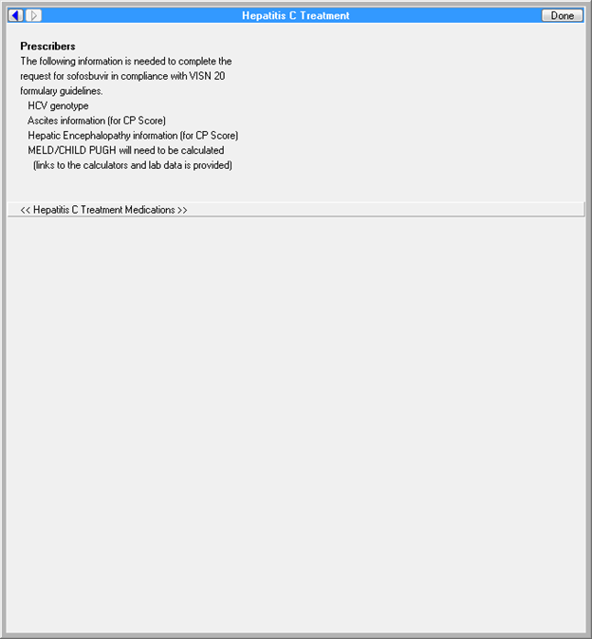

**Figure A.2. Template: Formulary Exception- Hepatitis C Virus (HCV) Output Phenolic Acid-responsive Transcriptional Regulator (PADR) (Image 1 of 5)**

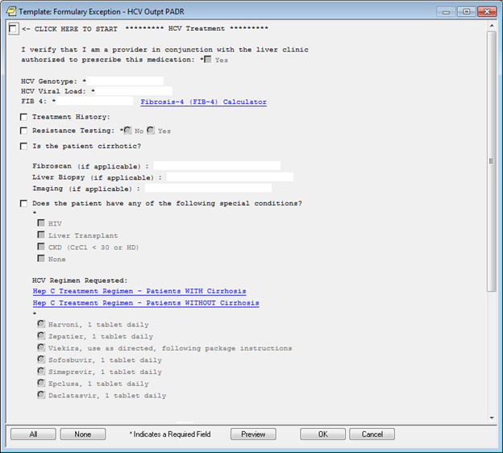

**Figure A.3. Template: Formulary Exception- Hepatitis C Virus (HCV) Output Phenolic Acid-responsive Transcriptional Regulator (PADR) (Image 2 of 5)**

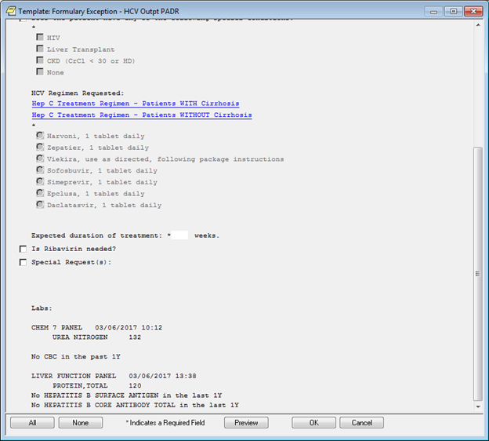

**Figure A.4. Template: Formulary Exception- Hepatitis C Virus (HCV) Output Phenolic Acid-responsive Transcriptional Regulator (PADR) (Image 3 of 5)**

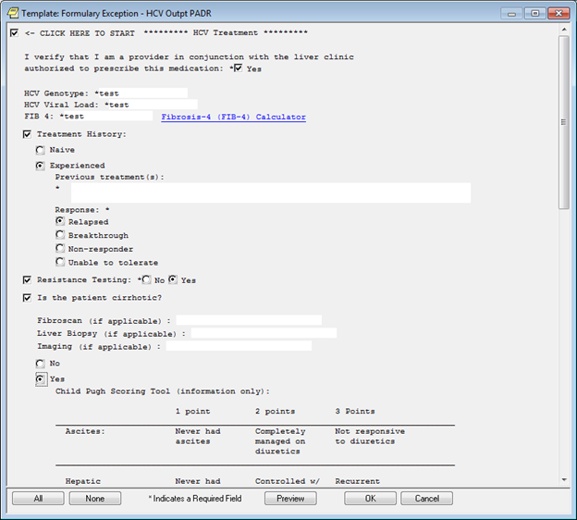

**Figure A.5. Template: Formulary Exception- Hepatitis C Virus (HCV) Output Phenolic Acid-responsive Transcriptional Regulator (PADR) (Image 4 of 5)**

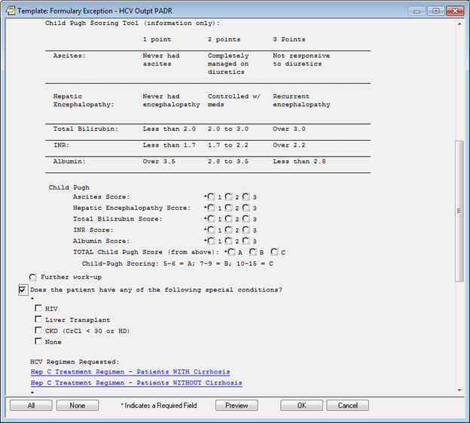

**Figure A.6. Template: Formulary Exception- Hepatitis C Virus (HCV) Output Phenolic Acid-responsive Transcriptional Regulator (PADR) (Image 5 of 5)**

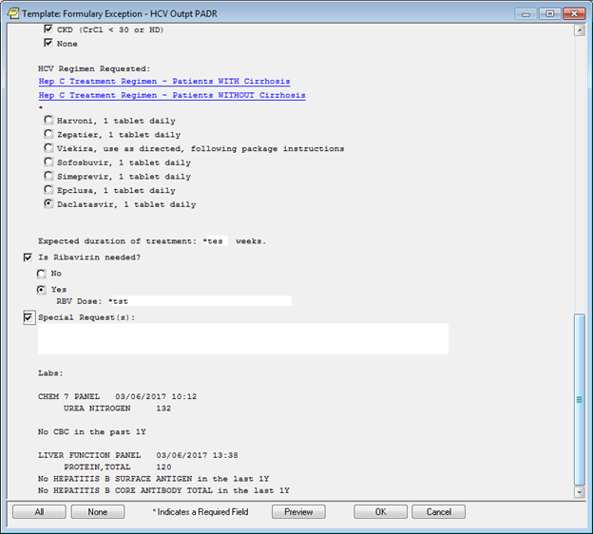

**Figure A.7. Fibrosis- 4 (FIB-4) Calculator (Image 1 of 2)**

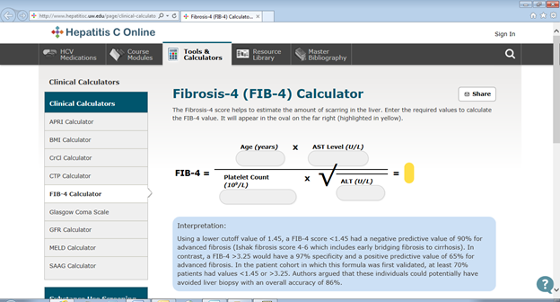

**Figure A.8. Fibrosis- 4 (FIB-4) Calculator (Image 2 of 2)**

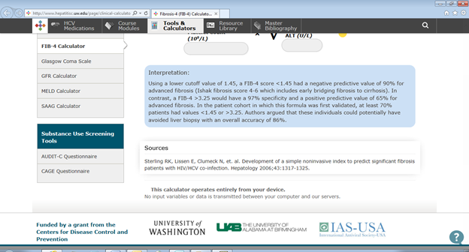

Figures A.9 through A.11 for the Hepatitis C - Ledipasvir/Sofosbuvir - Order Set are from the Portland VAMC.

**Figure A.9. Template: Hepatitis C Virus (HCV) Output Phenolic Acid-responsive Transcriptional Regulator (PADR) (Image 1 of 3)**

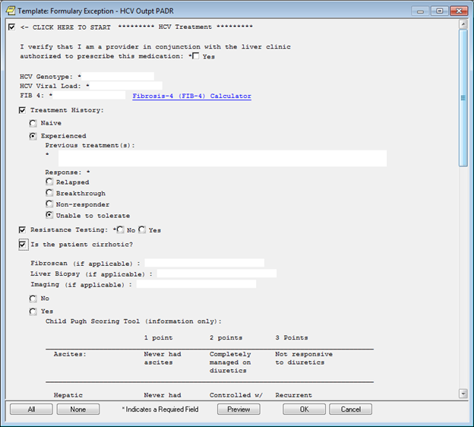

**Figure A.10. Template: Hepatitis C Virus (HCV) Output Phenolic Acid-responsive Transcriptional Regulator (PADR) (Image 2 of 3)**

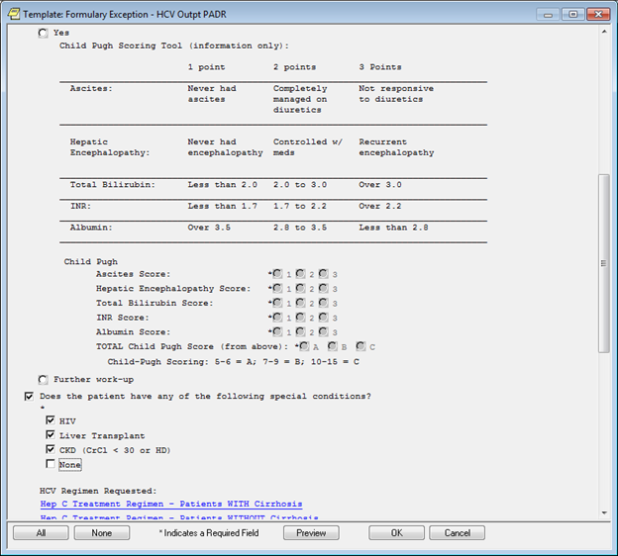

**Figure A.11. Template: Hepatitis C Virus (HCV) Output Phenolic Acid-responsive Transcriptional Regulator (PADR) (Image 3 of 3)**

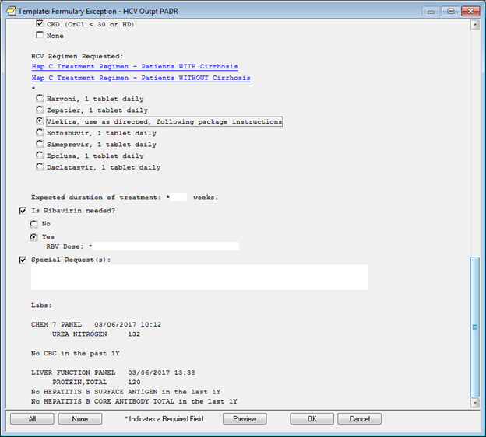

Tables A.1 through A.10 are from the Portland VAMC.

Patients Without Cirrhosis:

**Table A.1. Genotype 1**

|  |  |  |  |  |
| --- | --- | --- | --- | --- |
| **Treatment History** | **Baseline Viral Load** | **Preferred Regimen (Cost)** | **Alternative Regimen(s) (Cost)** | **Comments** |
| Treatment naive | <6 million IU/mL (Including HCV/HIV coinfection)  >6 million IU/mL | Harvoni x 8 weeks ($10,446) (Not African American)  Genotype 1a: Harvoni x 12 weeks ($15,669) Genotype 1b: Zepatier x 12 weeks ($15,522) | Genotype 1a: Zepatier x12 weeks in patients without baseline NS5A RAV ($15,522) Zepatier + Ribavirin x 16 weeks in patients with baseline NS5A RAV ($20,892) Genotype 1b: Harvoni x 12 weeks ($15,669) | Consider Zepatier for patients who are not candidates for Harvoni: -CrCl <30ml/min -Drug interactions (amiodarone) -Patients who are on high dose PPI and cannot hold PPI while on treatment |
| Treatment Experienced INF/RBV | N/A | Genotype 1a: Harvoni x 12 weeks ($15,669) *May consider ribavirin (-) RBV: 33/35 (94%) (+) RBV: 38/38 (100%) Genotype 1b: Zepatier x 12 weeks ($15,522) | Genotype 1a: Zepatier x12 weeks in patients without baseline NS5A RAV ($15,522) Zepatier + Ribavirin x 16 weeks in patients with baseline NS5A RAV ($20,892) Genotype 1b: Harvoni x 12 weeks ($15,522) |  |
| Treatment Experienced PI/INF/RBV | N/A | Genotype 1a: Harvoni x 12 weeks ($15,669) *May consider ribavirin (-) RBV: 50/52 (96%) (+) RBV: 51/51 (100%) Genotype 1b: Harvoni x 12 weeks ($15,669) *May consider ribavirin | Genotype 1a: Zepatier + Ribavirin x12 weeks in patients without baseline NS5A RAV ($15,522) Zepatier + Ribavirin x 16 weeks in patients with baseline NS5A RAV ($20,892) Genotype 1b: Zepatier + Ribavirin x 12 weeks ($15,522) |  |
| DAA Treatment Experienced *Non NS5A* | N/A | Harvoni + RBV x 12 weeks ($15,669) Epclusa +/- RBV x 12 weeks ($45,048.51) | Harvoni x 24 weeks ($31,338) | Likely will not need resistance testing |
| DAA Treatment Experienced *NS5A* | N/A | Zepatier + Sofosbuvir + RBV x 12 to 16 weeks (Consider 16 weeks for Y93 mutation) Epclusa + RBV x 24 weeks (if strong NS5A mutation is present) ($90,000) | Harvoni + RBV x 12 weeks (If no NS5A mutation) Harvoni x 24 weeks (if no NS5A mutation) ($31,338) Epclusa +/- RBV x 12 weeks (If no or weak NS5A mutation) | Obtain resistance testing (NS5A +/- PI) Consider waiting for future options if no urgency to treat Treatment option depends on duration of previous treatment, presence of NS5A RAS, and what kind of NS5A RAS |
| CrCl <30mL/min or ESRD | N/A | Genotype 1a: Zepatier x 12 weeks in patients without baseline NS5A RAV, 16 weeks with RAV ($15,522) Genotype 1b: Zepatier x 12 weeks ($15,522) | Genotype 1a: Viekira Pack + Low Dose RBV x 12 weeks ($15,522.36) Genotype 1b: Viekira Pack x 12 weeks ($15,522.36) | RBV 200mg daily if used in CKD/ESRD patients |

**Table A.2. Genotype 2**

|  |  |  |  |
| --- | --- | --- | --- |
| **Treatment History** | **Preferred Regimen (Cost)** | **Alternative Regimen(s)** | **Comments** |
| Naïve | Epclusa x 12 weeks ($45,048.51) | Harvoni + Ribavirin x 12 weeks ($15,669) |  |
| Treatment Experienced INF/RBV | Epclusa +/- RBV x 12 weeks ($45,048.51) | Daclatasvir + Sofobuvir +/- RBV x24 weeks per AASLD/IDSA ($164,220) | Epclusa x 12 achieved 97% SVR in GT2 DAA experienced non-NS5A |

**Table A.3. Genotype 3**

|  |  |  |  |
| --- | --- | --- | --- |
| **Treatment History** | **Preferred Regimen (Cost)** | **Alternative Regimen(s)** | **Comments** |
| Naïve | Epclusa x 12 weeks ($45,048.51) | Sofosbuvir + Daclatasvir x 12 weeks ($82,110) ALLY 3 SVR12- 97% (73/75) |  |
| Treatment Experienced INF/RBV | Epclusa + RBV x 12 weeks ($45,048.51) | Sofosbuvir + Daclatasvir + RBV x 12 weeks ($82,110) ALLY 3 SVR12- 94% (32/34) | Can omit RBV with Epclusa if no NS5A RAS |
| Treatment Experienced Sofosbuvir/RBV | Epclusa + RBV x 12 weeks ($45,048.51) | Daclatasvir + Sofosbuvir + RBV x 24 weeks per AASLD/IDSA ($164,220) | Epclusa x 12 achieved 85% SVR in GT 3 DAA experienced non-NS5A |
| Treatment Experienced Harvoni/RBV | Epclusa + RBV x 12 weeks (if no Y93 mutation) ($45,048.51) | Epclusa + RBV x 24 weeks (if Y93 mutation is present) ($90,000) | Unlikely to have Y93 mutation |
| Treatment Experienced Daclatasvir or Velpatasvir | Epclusa + RBV x 24 weeks ($90,000) - 13/16 (81%) SVR overall - 9/11 (82%) with Y93 mutation |  | Patients will almost certainly have the Y93 mutation SHOULD wait for new drugs if possible |

**Table A.4. Genotype 4**

|  |  |  |  |
| --- | --- | --- | --- |
| **Treatment History** | **Preferred Regimen (Cost)** | **Alternative Regimen(s)** | **Comments** |
| Naïve | Zepatier x 12 weeks ($15,522) | Harvoni x 12 weeks ($15,669) |  |
| Treatment experienced INF/RBV | Harvoni x 12 weeks ($15,669) | Zepatier + Ribavirin x 16 weeks ($20,892) Paritaprevir/Ritonavir/Ombitasvir + RBV (no Dasabuvir) x 12 weeks ($15,522) |  |
| DAA treatment experienced | Zepatier + Sofosbuvir + RBV x 12 to 16 weeks |  | Obtain resistance testing Consider waiting for future options if no urgency to treat |

**Table A.5. Genotype 5 and 6**

|  |  |  |  |
| --- | --- | --- | --- |
| **Treatment History** | **Preferred Regimen(s)** | **Alternative Regimen(s)** | **Comments** |
| Treatment Naïve and Experienced | Harvoni x 12 ($15,669) | Epclusa x 12 weeks ($45,048.51) | Limited data |

Patients With Cirrhosis:

**Table A.6. Genotype 1**

|  |  |  |  |
| --- | --- | --- | --- |
| **Treatment History** | **Preferred Regimen (Cost)** | **Alternative Regimen(s)** | **Comments** |
| Naïve | Genotype 1a: Harvoni + RBV x 12 weeks ($15,585.36) Genotype 1b: Zepatier x 12 weeks ($15,436.68) | Genotype 1a: Zepatier x12 weeks in patients without baseline NS5A RAV ($15,436.68) Zepatier + Ribavirin x 16 weeks in patients with baseline NS5A RAV ($20,582.24) Genotype 1b: Harvoni x 12 weeks ($15,585.36) Genotype 1: Epclusa x 12 weeks ($45,048.51) | Consider Zepatier for patients who are not candidates for Harvoni: - CrCl <30ml/min - Drug interactions (amiodarone) - Patients who are on high dose PPI and cannot hold PPI while on treatment |
| Treatment Experienced INF/RBV | Genotype 1a: Harvoni + RBV x 12 weeks ($15,585.36) Genotype 1b: Zepatier x 12 weeks ($15,436.68) | Genotype 1a: Zepatier x12 weeks in patients without baseline NS5A RAV ($15,436.68) Zepatier + Ribavirin x 16 weeks in patients with baseline NS5A RAV ($20,582.24) Genotype 1b: Harvoni + RBV x 12 weeks ($15,585.36) Genotype 1: Epclusa x 12 weeks ($45,048.51) |  |
| Treatment Experienced INF/RBV/PI | Genotype 1a: Harvoni + RBV x 12 weeks ($15,585.36) Genotype 1b: Zepatier +Ribavirin x 12 weeks ($15,436.68) | Genotype 1a: Zepatier + Ribavirin x12 weeks in patients without baseline NS5A RAV ($15,436.68) Zepatier + Ribavirin x 16 weeks in patients with baseline NS5A RAV ($20,582.24) Genotype 1b: Harvoni + RBV x 12 weeks ($15,585.36) |  |
| DAA Treatment Experienced *Non NS5A* | Harvoni + RBV x 24 weeks ($31,170.72) Epclusa + RBV x 12 weeks ($45,048.51) |  | Likely will not need resistance testing |
| DAA Treatment Experienced *NS5A* | Zepatier + Sofosbuvir + RBV x 12 to 16 weeks (Consider 16 weeks for Y93 mutation) Epclusa + RBV x 24 weeks (if strong NS5A mutation is present) | Harvoni + RBV x 24 weeks (if no NS5A mutation) ($31,170.72) Epclusa + RBV x 12 weeks (if no NS5A mutation) ($45,048.51) | Obtain resistance testing (both PI and NS5A) Consider waiting for future options if no urgency to treat Treatment option depends on duration of previous treatment, presence of NS5A RAS, and what kind/number of NS5A RAS |
| CrCl < 30 mL/min or ESRD | Genotype 1a: Zepatier x12 weeks in patients without baseline NS5A RAV ($15,522) Zepatier + Ribavirin x 16 weeks in patients with baseline NS5A RAV ($20,892) Genotype 1b: Zepatier x 12 weeks ($15,522) | Genotype 1a: Viekira Pack + Low Dose RBV x 12 weeks ($15,522.36) Genotype 1b: Viekira Pack x 12 weeks ($15,522.36) | RBV 200mg daily if used in CKD/ESRD patients |
| Decompensated Cirrhosis | Harvoni + RBV x 12 weeks ($15,585.36) Epclusa + RBV x 12 weeks ($45,048.51) | Harvoni x 24 weeks ($31,338) Epclusa x 12 weeks ($45,048.51) - 44/50 (88%) in GT1a - 16/18 (89%) in GT1b |  |

**Table A.7. Genotype 2**

|  |  |  |  |
| --- | --- | --- | --- |
| **Treatment History** | **Preferred Regimen (Cost)** | **Alternative Regimen(s)** | **Comments** |
| Naïve | Epclusa x 12 weeks ($45,048.51) | Harvoni + RBV x 16 weeks ($20,780.48) |  |
| Treatment experienced INF/RBV | Epclusa x 12 weeks ($45,048.51) | Harvoni + RBV x 16 weeks ($20,780.48) |  |
| Treatment Experienced Sofosbuvir/RBV | Epclusa + RBV x 12 weeks ($45,048.51) | Daclatasvir + Sofobuvir +/- RBV x24 weeks per AASLD/IDSA ($164,220) | Epclusa x 12 achieved 97% SVR in GT2 DAA experienced non-NS5A |
| Decompensated Cirrhosis | Epclusa +/- RBV x 12 weeks - 4/4 without RBV - 4/4 with RBV |  |  |

**Table A.8. Genotype 3**

|  |  |  |  |
| --- | --- | --- | --- |
| **Treatment History** | **Preferred Regimen (Cost)** | **Alternative Regimen(s)** | **Comments** |
| Naïve | Epclusa + RBV x 12 weeks ($45,048.51) | Daclatasvir + Sofosbuvir + Ribavirin x 12 weeks ($82,110) | Can omit RBC with Epclusa if no NS5A RAS |
| Treatment experienced INF/RBV | Epclusa + RBV x 12 weeks ($45,048.51) | Daclatasvir + Sofosbuvir + Ribavirin x 12 ($82,110) | Can omit RBV with Epclusa if no NS5A RAS |
| Treatment Experienced Sofosbuvir/RBV | Epclusa + RBV x 12 weeks ($45,048.51) | Daclatasvir + Sofosbuvir + Ribavirin x 24 weeks ($164,220); Per AASLD) | Epclusa x 12 achieved 85% SVR in GT 3 DAA experienced non-NS5A |
| Treatment Experienced Harvoni/RBV | Epclusa + RBV x 12 weeks (if no Y93 mutation) ($45,048.51) | Epclusa + RBV x 24 weeks (if Y93 mutation is present or decomp cirrhosis) ($90,000) |  |
| Treatment Experienced Daclatasvir or Velpatasvir | Epclusa + RBV x 24 weeks ($90,000) - 13/16 (81%) SVR overall - 9/11 (82%) with Y93 mutation |  | Patients will almost certainly have the Y93 mutation SHOULD wait for new drugs if possible |
| Decompensated Cirrhosis | Epclusa + RBV x 12 weeks |  |  |

**Table A.9. Genotype 4**

|  |  |  |  |
| --- | --- | --- | --- |
| **Treatment History** | **Preferred Regimen (Cost)** | **Alternative Regimen(s)** | **Comments** |
| Naïve | Zepatier x 12 weeks ($15,436.68) | Harvoni x 12 weeks ($15,585.36) | Omit dasabuvir from Viekira pack when using it to treat GT 4 |
| Treatment experienced INF/RBV | Harvoni x 12 weeks ($15,585.36) | Zepatier + Ribavirin x 16 weeks ($20,582.24) Paritaprevir/Ritonavir/Ombitasvir + RBV x 12 weeks ($15,522.36) | Omit dasabuvir from Viekira pack when using it to treat GT 4 |
| DAA treatment experienced | Zepatier + Sofosbuvir + RBV x 12 to 16 weeks |  | Obtain resistance testing Consider waiting for future options if no urgency to treat |
| Naïve CrCl 30 mL/min or ESRD | Zepatier x 12 weeks ($15,522) | Viekira Pack + RBV x 12 weeks ($15,522.36) | RBV 200mg daily if used in CKD/ESRD patients |
| Decompensated Cirrhosis | Harvoni + RBV x 12 weeks ($15,585.36) | Epclusa +/- RBV x 12 weeks ($45,048.51) - 4/4 without RBV - 2/2 with RBV |  |

**Table A.10. Genotype 5 and 6**

|  |  |  |  |
| --- | --- | --- | --- |
| **Treatment History** | **Preferred Regimen (Cost)** | **Alternative Regimen(s)** | **Comments** |
| Treatment Naïve and Experienced | Harvoni x 12 weeks ($15,585.36) | Epclusa x 12 weeks ($45,048.51) | Limited data |
| Decompensated Cirrhosis | Harvoni + RBV x 12 weeks ($15,585.36) | Epclusa + RBV x 12 weeks ($45,048.51) |  |

Figures A.12 through A.19 for the Hepatitis C - Ledipasvir/Sofosbuvir - Order Set are from the Greater Los Angeles VAMC.

**Figure A.12. Reminder Dialog Template: Hepatitis C Clinic Subjective Objective Assessment Plan (SOAP) (I &II combined) (Image 1 of 8)**

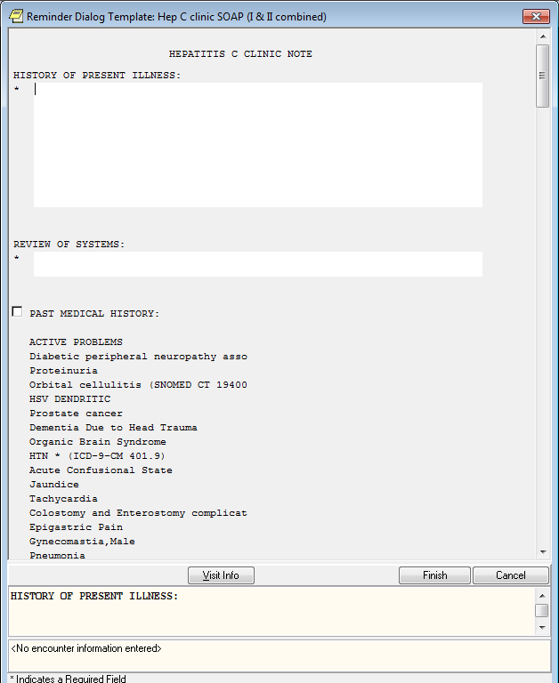

**Figure A.13. Reminder Dialog Template: Hepatitis C Clinic Subjective Objective Assessment Plan (SOAP) (I &II combined) (Image 2 of 8)**

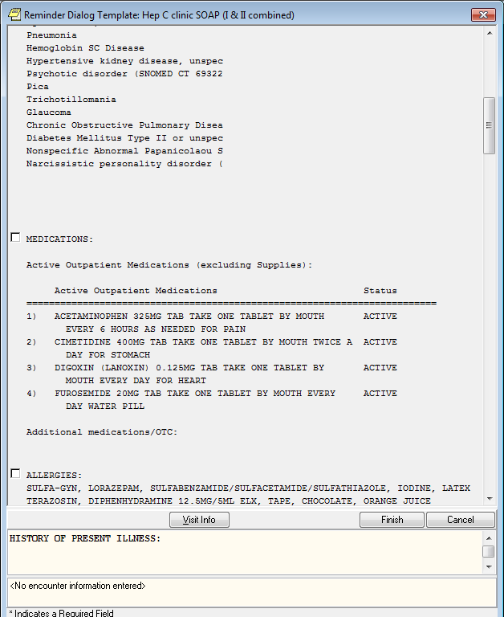

**Figure A.14. Reminder Dialog Template: Hepatitis C Clinic Subjective Objective Assessment Plan (SOAP) (I &II combined) (Image 3 of 8)**

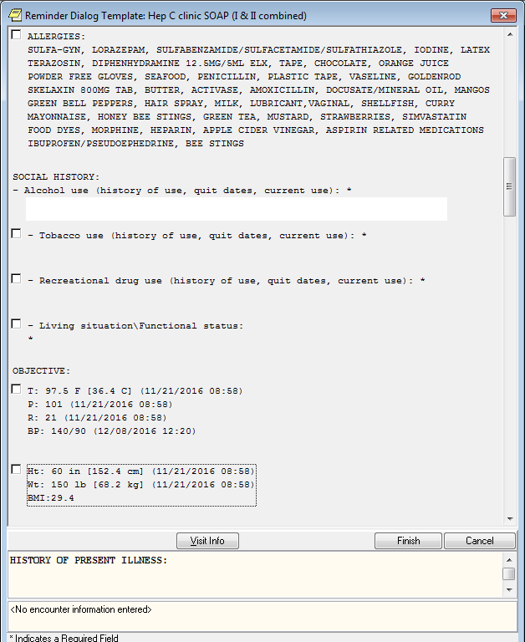

**Figure A.15. Reminder Dialog Template: Hepatitis C Clinic Subjective Objective Assessment Plan (SOAP) (I &II combined) (Image 4 of 8)**

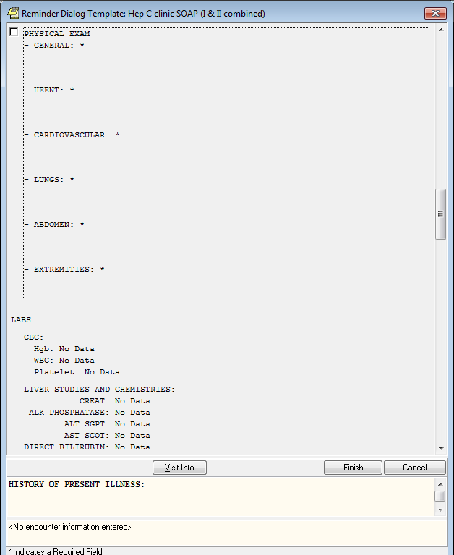

**Figure A.16. Reminder Dialog Template: Hepatitis C Clinic Subjective Objective Assessment Plan (SOAP) (I &II combined) (Image 5 of 8)**

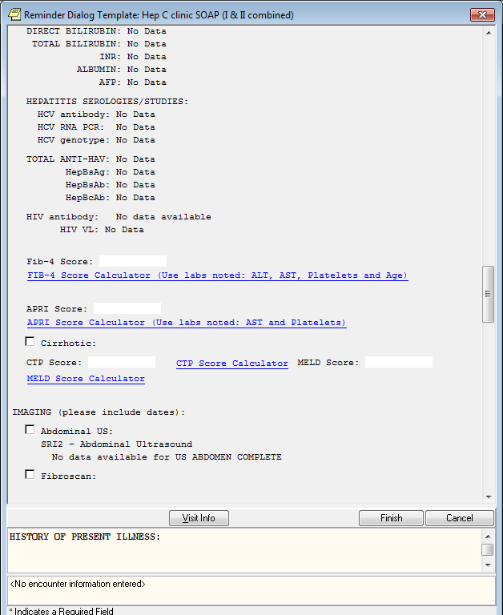

**Figure A.17. Reminder Dialog Template: Hepatitis C Clinic Subjective Objective Assessment Plan (SOAP) (I &II combined) (Image 6 of 8)**

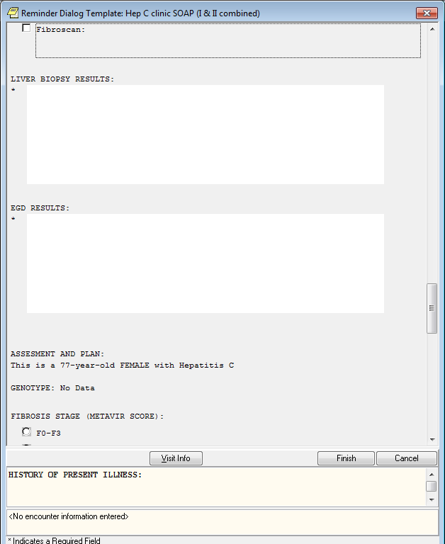

**Figure A.18. Reminder Dialog Template: Hepatitis C Clinic Subjective Objective Assessment Plan (SOAP) (I &II combined) (Image 7 of 8)**

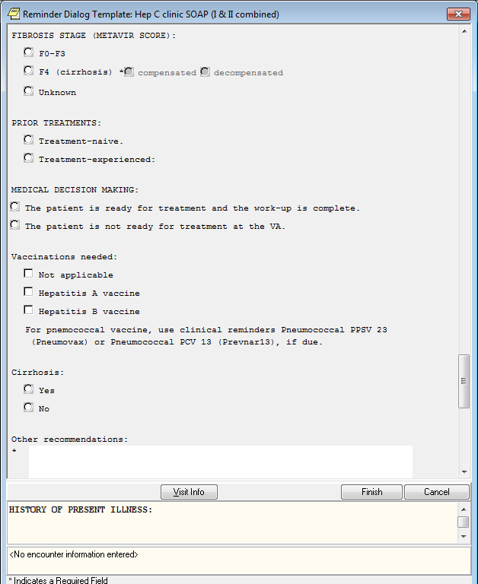

**Figure A.19. Reminder Dialog Template: Hepatitis C Clinic Subjective Objective Assessment Plan (SOAP) (I &II combined) (Image 8 of 8)**

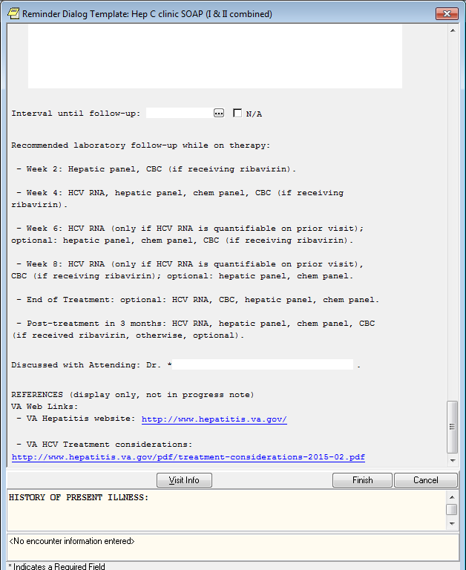

APRI Score: http://www.hepatitisc.uw.edu/page/clinical-calculators/apri

CTP Score: http://www.hepatitisc.uw.edu/page/clinical-calculators/ctp

MELD Score: http://www.hepatitisc.uw.edu/page/clinical-calculators/meld

VA hepatitis website: http://www.hepatitis.va.gov/

**Appendix B. Clinical Guidelines**

The below links are from the Greater Los Angeles VAMC.

Aspartate aminotransferase (AST) to Platelet Ratio Index (APRI) Score: http://www.hepatitisc.uw.edu/page/clinical-calculators/apri

CTP Score: http://www.hepatitisc.uw.edu/page/clinical-calculators/ctp

Model for End-Stage Liver Disease (MELD) Score: http://www.hepatitisc.uw.edu/page/clinical-calculators/meld

VA hepatitis website: http://www.hepatitis.va.gov/

**Appendix C. Basic Laboratory Panel Definition**

* Blood Urea Nitrogen
* Calcium
* Chloride
* CO2 (Carbon Dioxide, Bicarbonate)
* Creatinine
* Glucose
* Potassium
* Sodium

**Acronyms**

APRI AST to Platelet Ratio Index

AST Aspartate Aminotransferase

BMI Body Mass Index

CDS Clinical Decision Support

CO2 Carbon Dioxide, Bicarbonate

CT Computed Tomography

CTP Child Turcotte Pugh Class

FIB-4 Fibrosis-4

HAVAb Hepatitis A Antibody

HBcAb Hepatitis B Core Antibody

HBsAB Hepatitis B Surface Antibody

HBsAg Hepatitis B Surface Antigen

HCG Human Chorionic Gonadotropin

HCV Hepatitis C Virus

HL7 Health Level 7

INR International Normalized Ratio

KBS Knowledge Based Systems

KNART Knowledge Artifact

MELD Model for End-Stage Liver Disease

MRI Magnetic Resonance Imaging

OIIG Office of Informatics and Information Governance

PADR Phenolic Acid - Responsive

RNA Ribonucleic Acid

SME Subject Matter Expert

SOAP Subjective Objective Assessment Plan

TO Task Order

VA Department of Veteran Affairs

VAMC VA Medical Center